Assignment 4: SDN
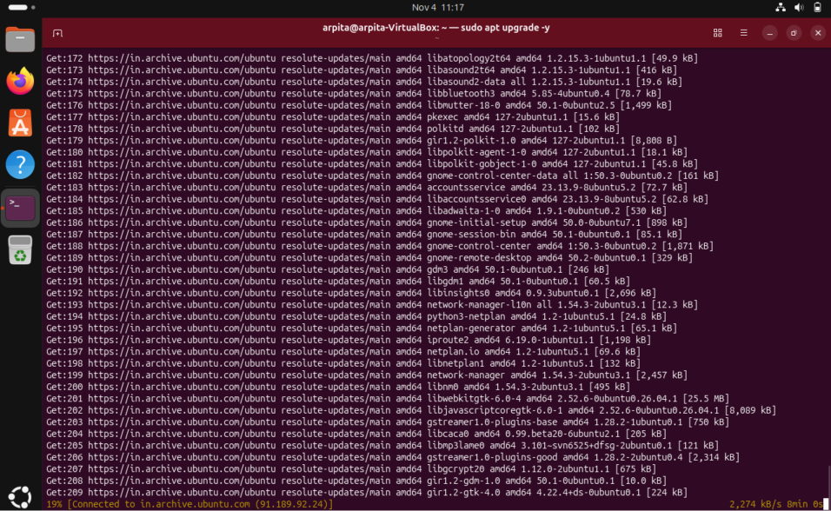
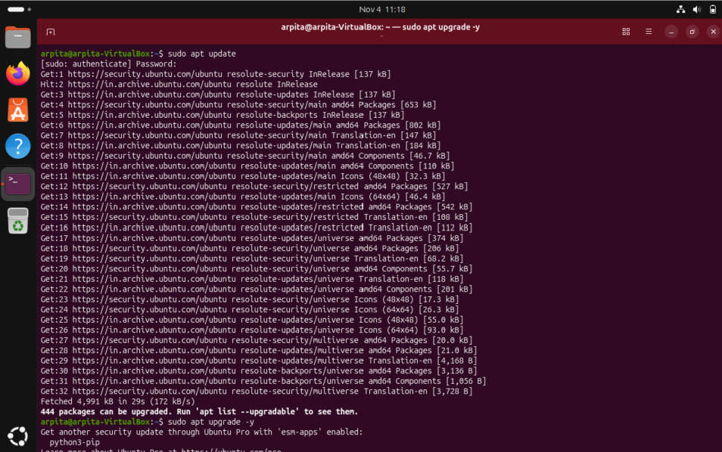
- Update Ubuntu
- Install Mininet
- Install Open vSwitch
- Check Open vSwitch
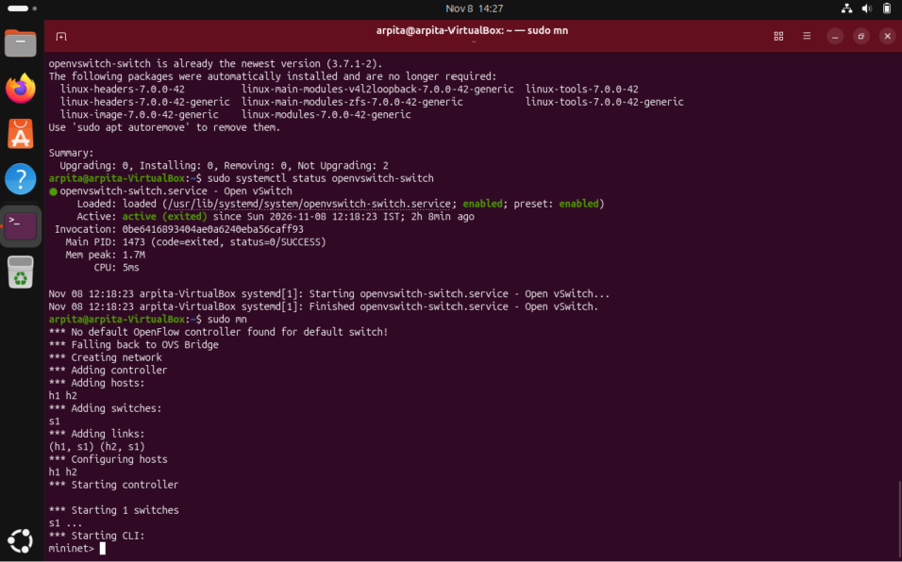
- Test Mininet

sudo mn
Starts a basic Mininet network.
mininet> nodes
Displays the available virtual hosts and switch.
mininet> pingall
Tests connectivity between the virtual hosts.
mininet> exit
Exits Mininet.
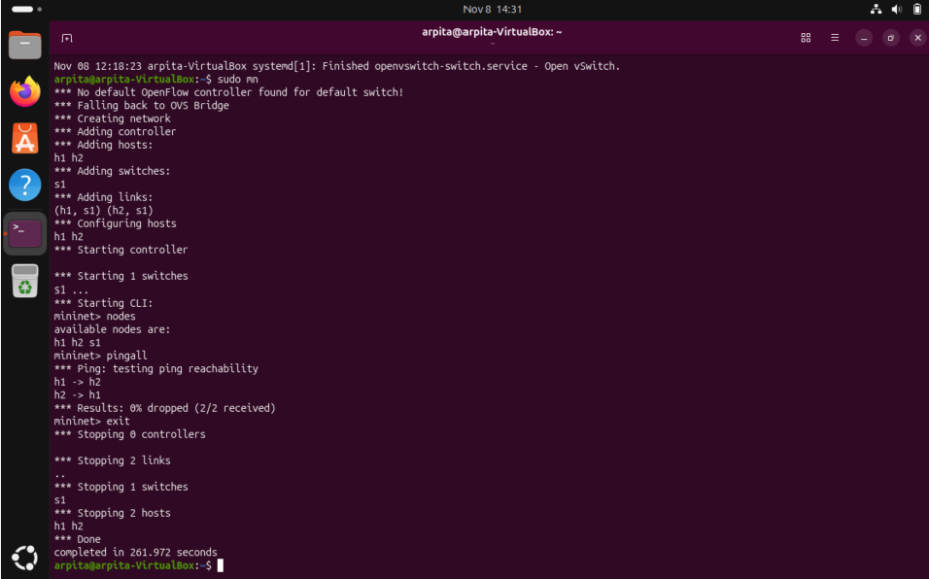

- Install Python and Virtual Environment
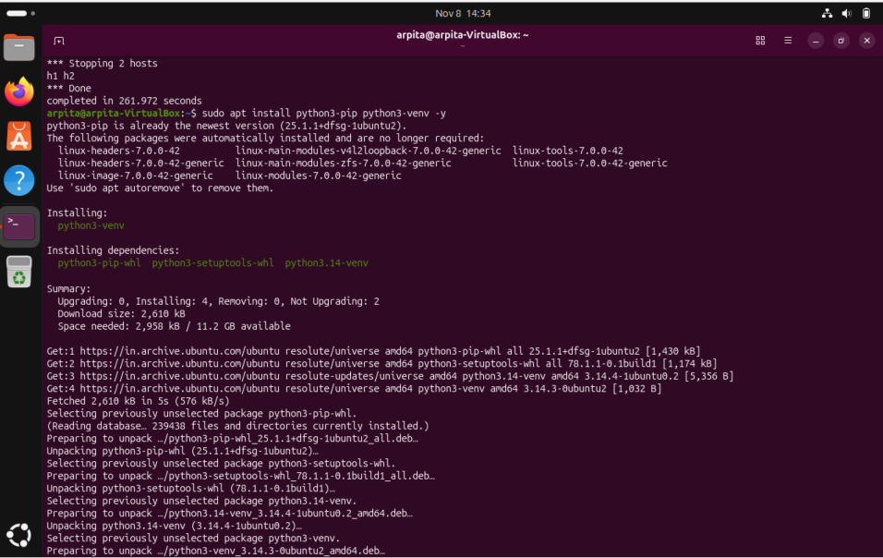

- Create Ryu Environment
- Install Ryu
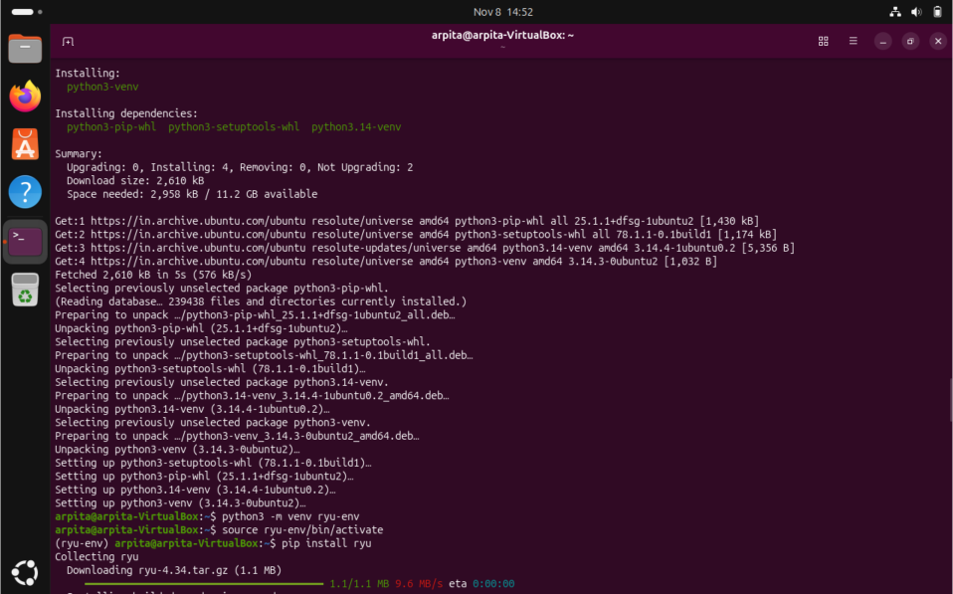

- Test Ryu Installation
- Start Ryu Controller

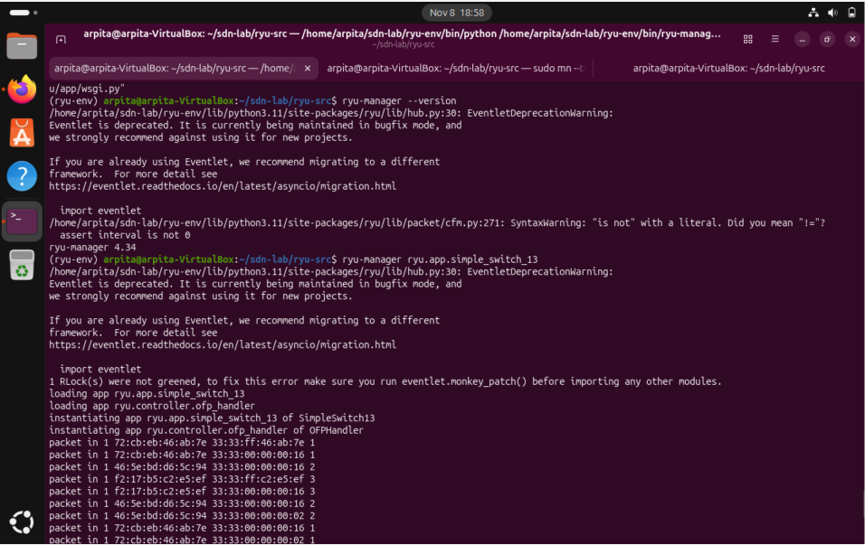

- Create Mininet SDN Topology
- Check Nodes
- Check Connections
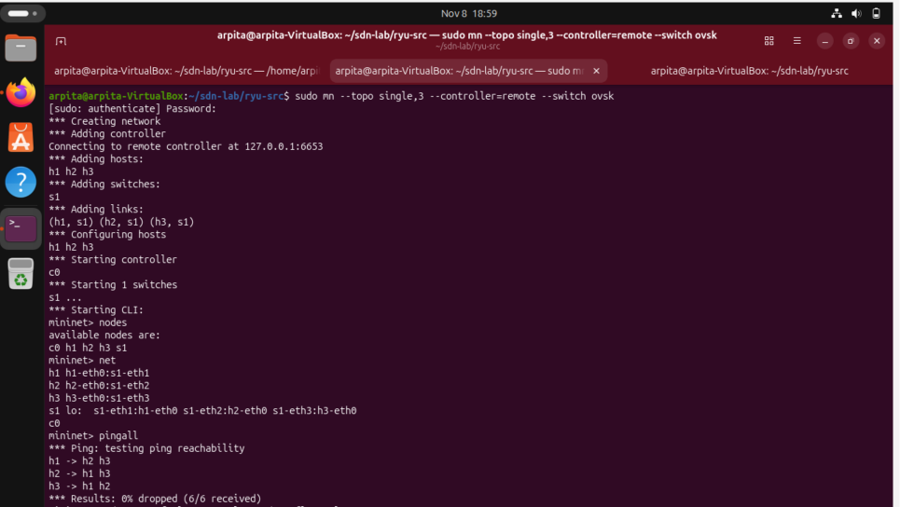
- Test Connectivity

- View Flow Rules
- Add a Simple Filtering Rule
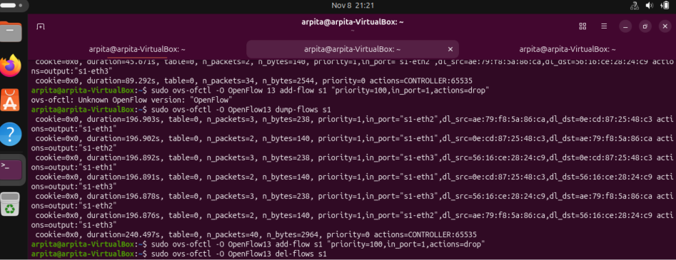
- Test the Filtering Rule
mininet> h1 ping h2
Checks the effect of the filtering rule on H1's traffic.
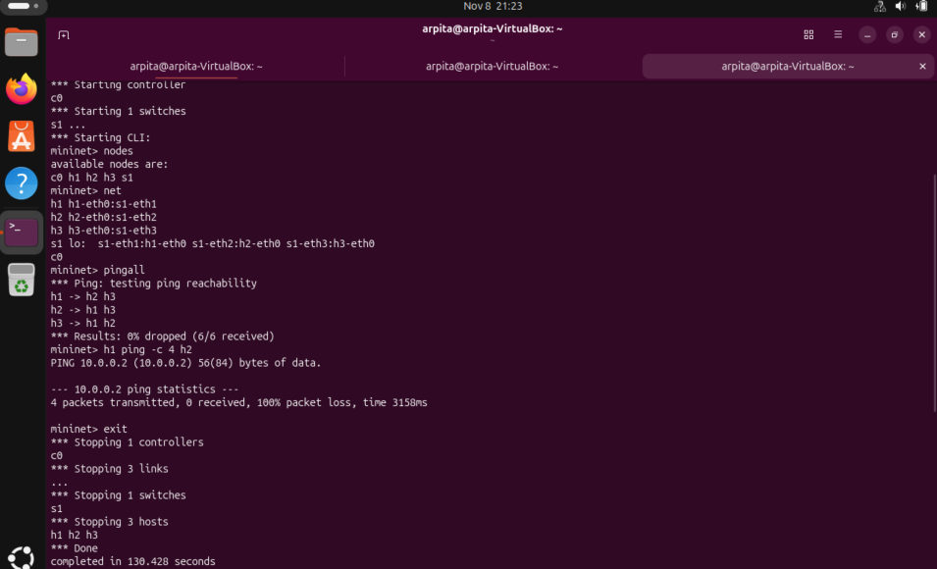
- Remove Flow Rules
sudo ovs-ofctl -O OpenFlow13 del-flows s1
- Clean Mininet
sudo mn -c
Cleans up Mininet interfaces and processes.


